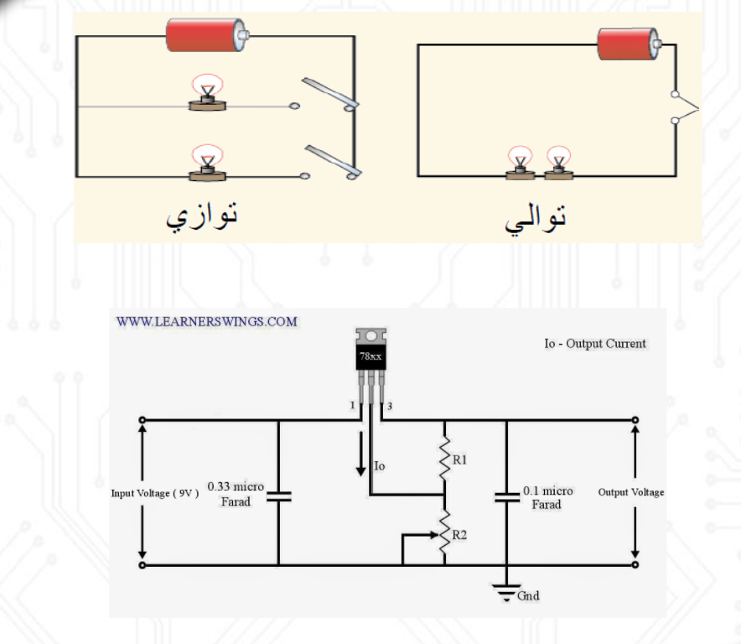

Running a series circuit helps to provide the same amount of current to each LED. This means each LED in the circuit will be the same brightness and will not allow a single LED to hog more current than another. When each LED is receiving the same current it helps eliminate issues like thermal runaway.

So it better to connect our circuit in **Series**